Selection of teaching and learning materials – module »Vocational orientation in the commercial sector« - Unit D1 – Collecting ideas
Excercise 4.6. ONE-MINUTE COLLECTION OF IDEAS
In one-minute, list all the possibilities of using an office clip that you can imagine. Here are the following tips:
- important is the quantity and not the quality of ideas.
- write down every idea. Do not judge or criticize them.
- be relaxed, playful, even funny.
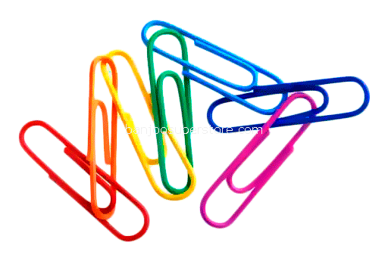
- change your established way of looking at objects (see from different point of views: like insect, bird, designer, indigenous from Africa, ect.)
- Ask yourself "what if ...?" (for example, what if the buckle would be straightened, if several clips were connected, ...?)
Possibilities of use
How did you do it? Could you write a full minute? Did you run out of ideas? Did ideas appear also after one minute?
Work in pairs and group check of collected ideas
Check the collected ideas and in 3 minutes make a common list. Then get two pairs together and make in 3 min common list, and repeat till all pairs went through. One participant make a report of common list.
How many different ideas are collected in whole group?

